GZD WEBSITE

HOME Page

Part 1
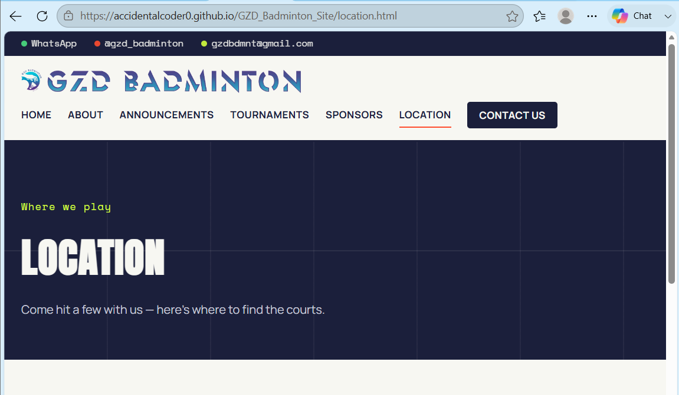
ADD
- MEMBERSHIP link next to ANNOUNCEMENTS
- LEAGUES link next to TOURNAMENTS
- VP transparent logo, I will provide a new one, or please remind me for a new copy

Part 2

- Add clickable link to VP’s logo to direct them to VP’s Instagram or retail website
- Also change to transparent PNG – will provide a new PNG image for you
- Add logo for Uplift Physio, they are also our official sponsor – will provide a new PNG image to you

Others
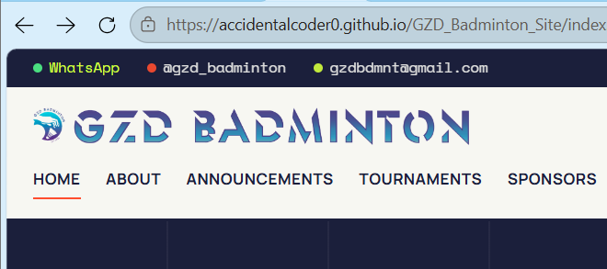
- Would it be possible to enlarge the GZD logo, and leave a slightly larger space between the contact above and headline links below?
- Possible to add Whatsapp, Instagram and an email icon or emoji next to the contacts?

ABOUT Page

All good.

ANNOUNCEMENTS Page

All good.

TOURNAMENTS Page

Part 1
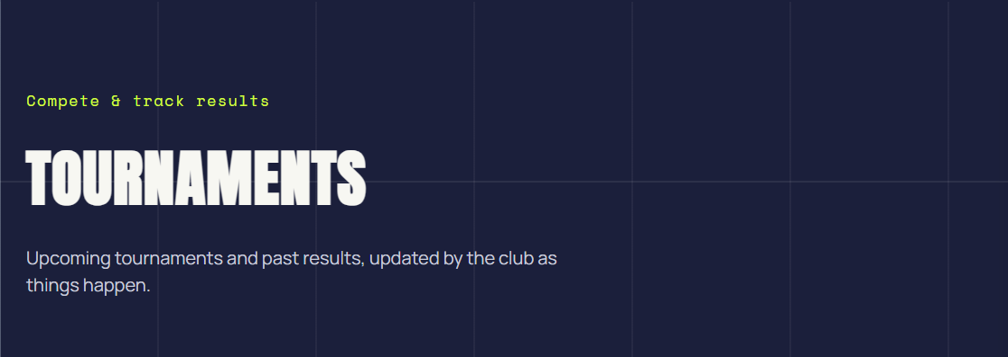
- Does this mean that I will have to provide you with the previous tournaments records? If yes, please see Placeholder.docx.

Part 2
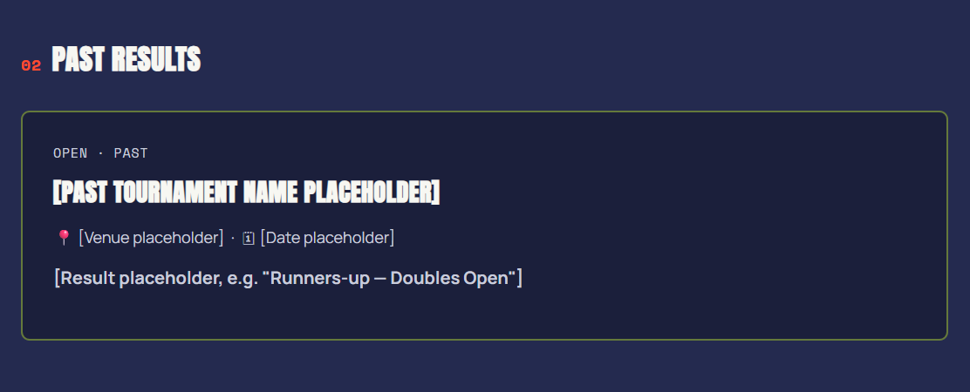
- Same as Part 1 of this section.

SPONSORS Page

Part 1
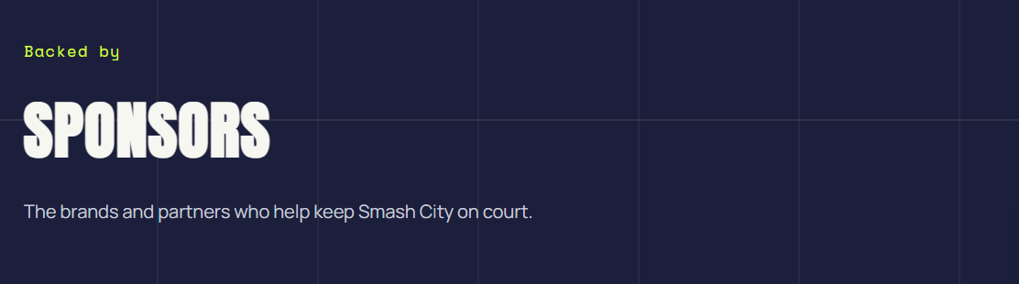
- Not sure if it’s meant to be Smash City, or the code was not amended, should be “who help keep GZD Badminton on court”.

Part 2

- Please include clickable link directing to VP’s Instagram or retail website.
- Please change to transparent PNG image, will provide a new PNG to you.
- Please add Uplift Physio too, will provide logo to you.
FURTTHER ADD – PARTNERSHIPS Page next to SPONSOR

Part 1
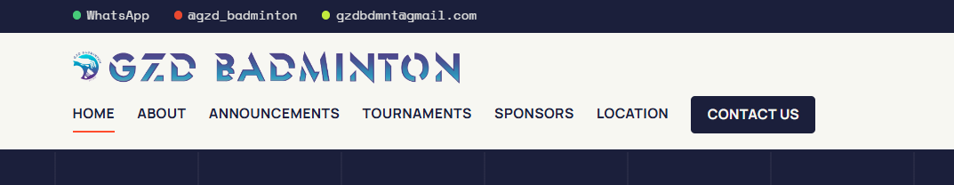
- Please include our new partners from British Heart Foundation, and Manchester ANC, I am still waiting for them to provide the details and logo, you can just put a placeholder in the meantime.

LOCATION Page

Part 1
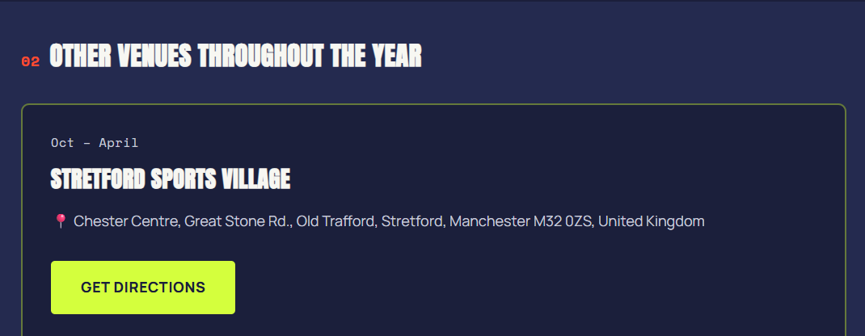
- Should be Sept – May each year, and June to Sept. We always take a break after the last session in May and continue in June.
- We have also updated our new venue to Manchester College, Openshaw. We no longer hosting sessions at Stretford (their courts are too bad).

